26th Sunday in Ordinary Time

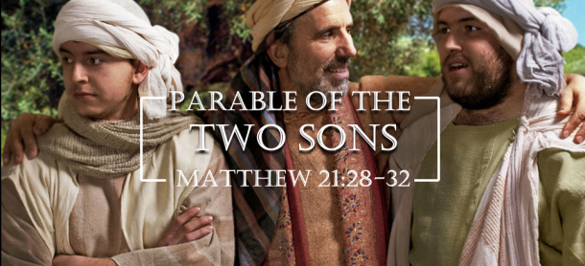

1st Reading: Ezekiel 18:25-28
God deals justly with us, forgiving the sinner who repents and rewarding those who persevere
Yet you say, “The way of the Lord is unfair.” Hear now, O house of Israel: Is my way unfair? Is it not your ways that are unfair? When the righteous turn away from their righteousness and commit iniquity, they shall die for it; for the iniquity that they have committed they shall die.
Again, when the wicked turn away from the wickedness they have committed and do what is lawful and right, they shall save their life. Because they considered and turned away from all the transgressions that they had committed, they shall surely live; they shall not die.

Responsorial: Psalm 24:4-9
Response: Remember your mercies, O Lord
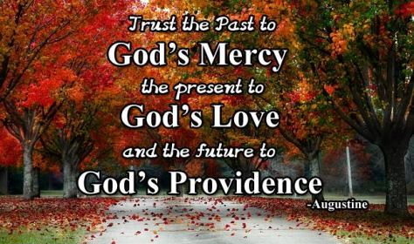
Lord, make me know your ways.
Lord, teach me your paths.
Make me walk in your truth, and teach me:
for you are God my saviour. Resp:
Remember your mercy, Lord,
and the love you have shown from of old.
Do not remember the sins of my youth.
In your love remember me,
because of your goodness, O Lord. Resp:
The Lord is good and upright.
He shows the path to those who stray,
he guides the humble in the right path;
he teaches his way to the poor. Resp:

2nd Reading: Philippians 2:1-11
Unity depends on Christians imitating the humility of Christ who became obedient unto death
If then there is any encouragement in Christ, any consolation from love, any sharing in the Spirit, any compassion and sympathy, make my joy complete: be of the same mind, having the same love, being in full accord and of one mind. Do nothing from selfish ambition or conceit, but in humility regard others as better than yourselves. Let each of you look not to your own interests, but to the interests of others. Let the same mind be in you that was in Christ Jesus, who, though he was in the form of God, did not regard equality with God as something to be exploited, but emptied himself, taking the form of a slave, being born in human likeness. And being found in human form, he humbled himself and became obedient to the point of death-even death on a cross. Therefore God also highly exalted him and gave him the name that is above every name, so that at the name of Jesus every knee should bend, in heaven and on earth and under the earth, and every tongue should confess that Jesus Christ is Lord, to the glory of God the Father.
Gospel Acclamation:
Alleluia, Alleluia!
My sheep listen to my voice, says the Lord;
I know them, and they follow me.
Alleluia!

Gospel: Matthew 21:28-32
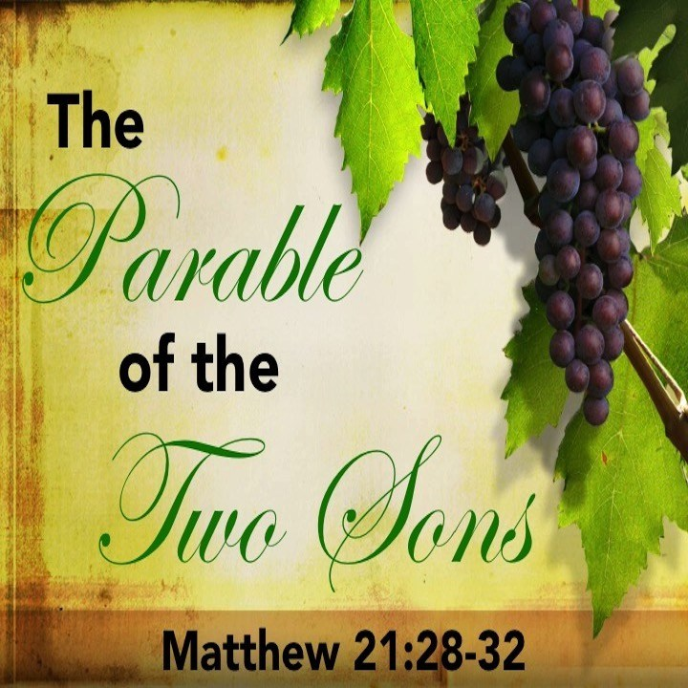
The parable of the two sons reminds us that good actions speak louder than fine words
Jesus said to the chief priests and the elders: “What do you think? A man had two sons; he went to the first and said, “Son, go and work in the vineyard today.” He answered, “I will not’; but later he changed his mind and went. The father went to the second and said the same; and he answered, “I go, sir’; but he did not go. Which of the two did the will of his father?” They said, “The first.” Jesus said to them, “Truly I tell you, the tax collectors and the prostitutes are going into the kingdom of God ahead of you. For John came to you in the way of righteousness and you did not believe him, but the tax collectors and the prostitutes believed him; and even after you saw it, you did not change your minds and believe him.”

Reflections:
A theme common to all three readings is that of changing one’s mind. Our capacity to change our minds leaves us open to hazard and to hope; hazard when we choose to “renounce our integrity and to commit sin, hope when we choose to renounce sin to become law-abiding and honest” (Isaiah.)
The Gospel story shows us the nobility of a humble change of mind. The first son “thought the better of it.” He was open to change, to better thoughts. The second son was set and closed. The ability to change one’s mind is essential to all healthy relationships. A mind that is closed, whether from pride, stubbornness or stupidity, tends to destroy all relationships, for example: when we refuse to admit a mistake, when we are unwilling to apologise and change our ways, when we persist in prejudice against a person or group, when we think we know it all.
The second reading, from Philippians, talks of a more specific and positive change of mind: “in your minds, you must be the same as Christ Jesus’, or as an older translation put it, “Let this mind be in you which was in Christ Jesus.” This is the direction in which we must be constantly changing our minds day by day.
St. Paul emphasises one aspect in particular of the mind of Christ – his humble openness and self-emptying in contrast to the conceited grasping and clinging of Adam: “He did not cling to (or grasp at) his equality with God (as Adam did in Eden) but emptied himself..”
Ever since Adam, we are all born as clingers and graspers. The new-born babe has to have a tight grip, and as we get older the grip often gets stronger. Clinging permeates all of life; we cling to people (possessiveness) ; to things (greed) ; to power and position (ambition) ; we cling to opinions (pride.) At the root of our clinging lies fear and insecurity. The apparently strong person who clings aggressively to set ways or ideas is in reality full of fear. Notice your physical reactions to fright; you clench up and grasp at something or someone, as a frightened child clings to its mother.
In the Buddhist tradition, clinging is seen as the root of all suffering. When you are unhappy, it can be enlightening to pursue the question “What am I clinging to?” It might be an idea, a plan, an expectation, power, possessions, reputation, a place, a person, health, even life itself. All wise traditions recommend a light grasp of everything. Anxious clinging leads to misery. As soon as we begin to relax our tight grasp and let go, we begin to be free and happy. With the idea of “Letting go”, we can say that it is equivalent for “self-emptying.”
The Lord Jesus did not cling. He knew that reality could be trusted, because at the heart of reality is “Abba – dear Father,” and that underneath everything, even death, are the everlasting arms. So he did not cling even to life, “accepting death, death on a cross.” “Into your hands, I commend my spirit.” May this mind be in us which was in Christ Jesus. Amen.

